**ASP.NET Project**

***Submitted By:***

**Akshay Khanna**

**Sania Labana**

**Vikram Thakur**



ITC-Hotel Booking

**Index Table**

|  |  |  |
| --- | --- | --- |
| **S.No.** | **Title** | **Page Number** |
| 1. | Index Table | 2 |
| 2. | About this Project | 3 |
| 3. | Tools Used | 4 |
| 4. | Snapshots – Execution in a Web Browser | 5 – 15 |
| 5. | Snapshots – Databases | 16 – 20 |
| 6. | Snapshots – Code | 20 - 29 |
|  |  |  |
|  |  |  |

**About This Project:**

This Website Allows Users to Book 5 of the major ITC hotels. Users can simply click on the Book Hotel tab on the menu bar or select a specific hotel from any of the displayed pictures.

This opens up a page where on left side of the webform user can see hotel logo and details in a panel, an image slider that automatically/manually slides the images of that specific hotel and the images of the rooms of that hotel in another datalist below.

User can also change hotel via dropdown menu on right side of image slider. Also, information about that hotel is displayed above the rooms’ datalist. User can click on any of the rooms’ hyperlink.

This redirects the user to the hotel booking webform which contains check availability in view 1, if rooms available, users may enter details in view 2, and finally are shown the price and their userID in view 3 and asked to confirm the booking.

If user confirms the Booking, database is updated on click of that button and a confirmation message is displayed.

In case any user who has booked using this website wishes to cancel his booking, he/she may click on cancel booking tab on menu bar and will be redirected to another page with a multiview, asking booking ID and their email, in next view they are asked to visually verify the booking details and click cancel if they wish so. Finally a Confirmation prompt is displayed for the ultimate cancellation.

In addition to these, there are About US, FAQ and Contact Pages which perform their expected operations.

**TOOLS USED**

**FRONT END:**  Microsoft Visual Studio 2010

**BACK END:** Microsoft SQL SERVER 2008

**Other Tools Used**:

1. CSS
2. Javascript
3. AJAX
4. Crystal Report

**SNAPSHOTS – Execution in a Web Browser**

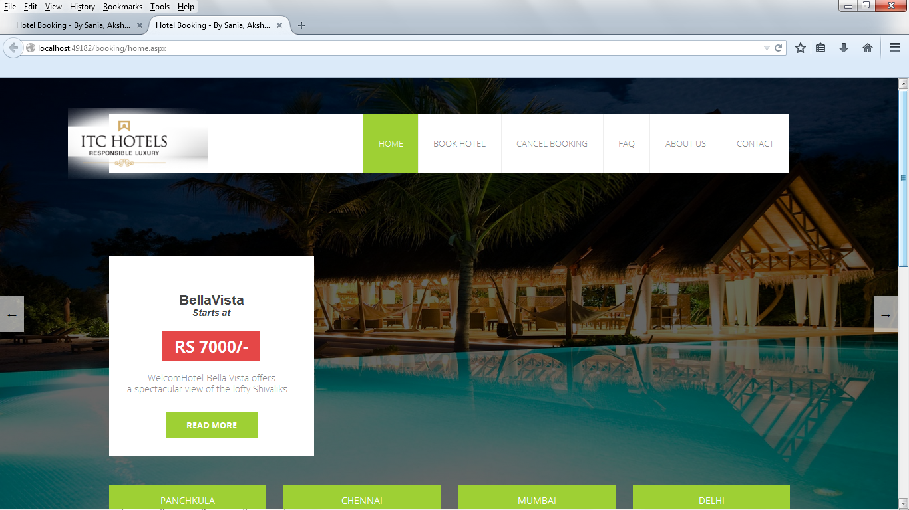

**Home-Top**

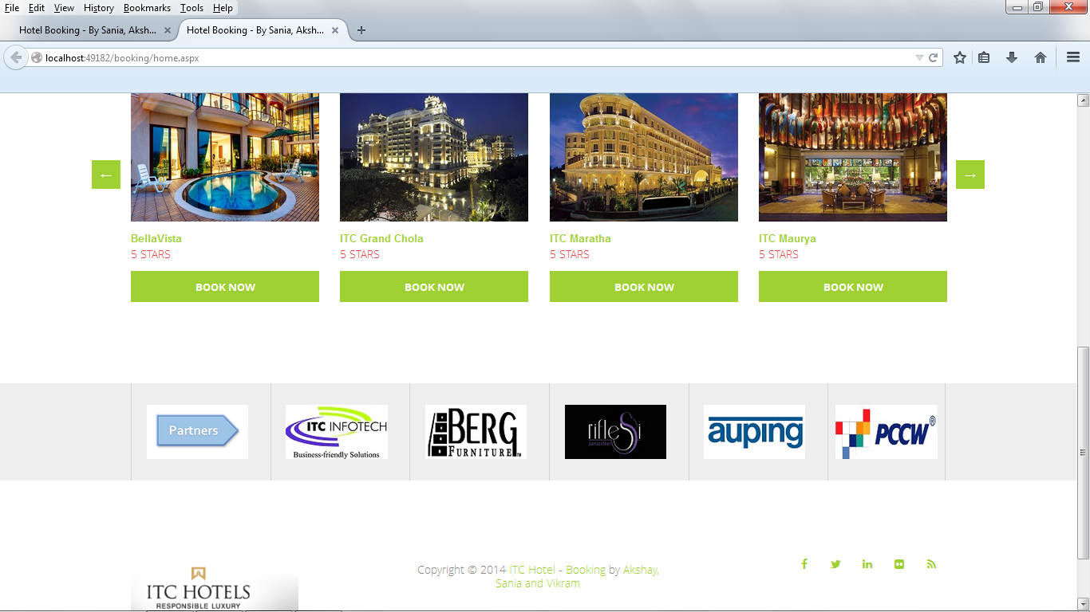

**Home – Bottom**

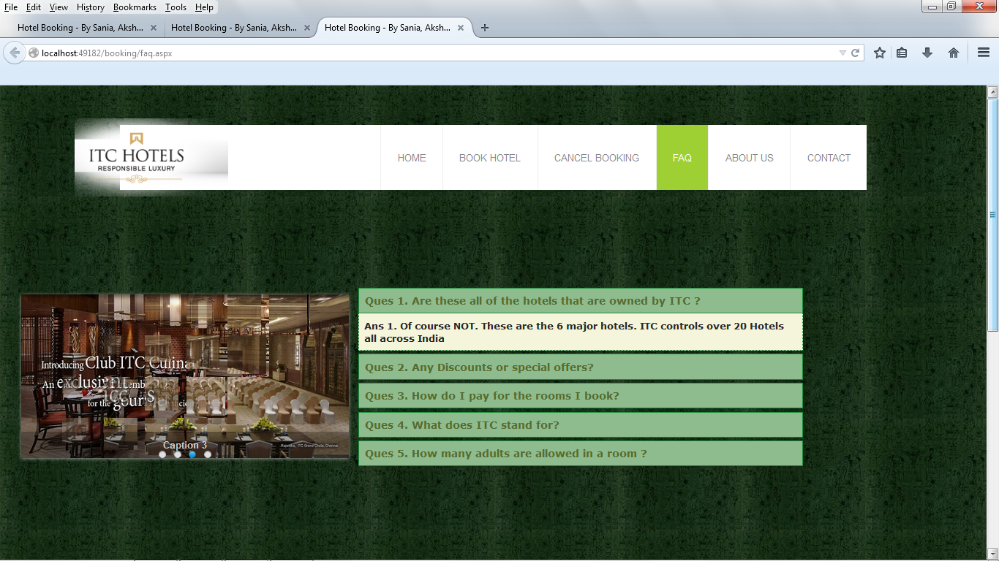

**FAQ page – Accordion/Accordion Pane**

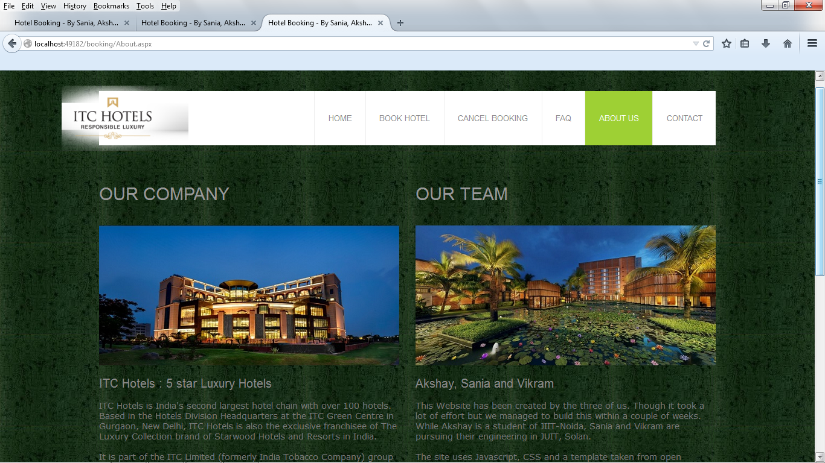

**About Us Page**

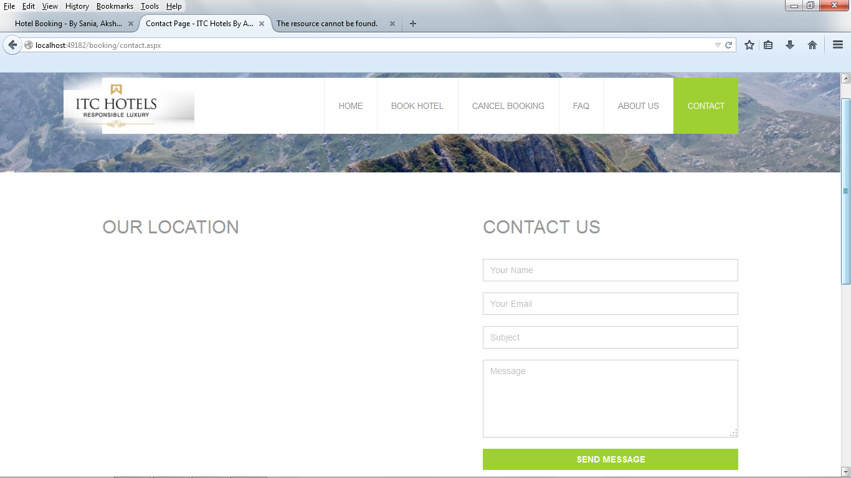

**Contact Page**

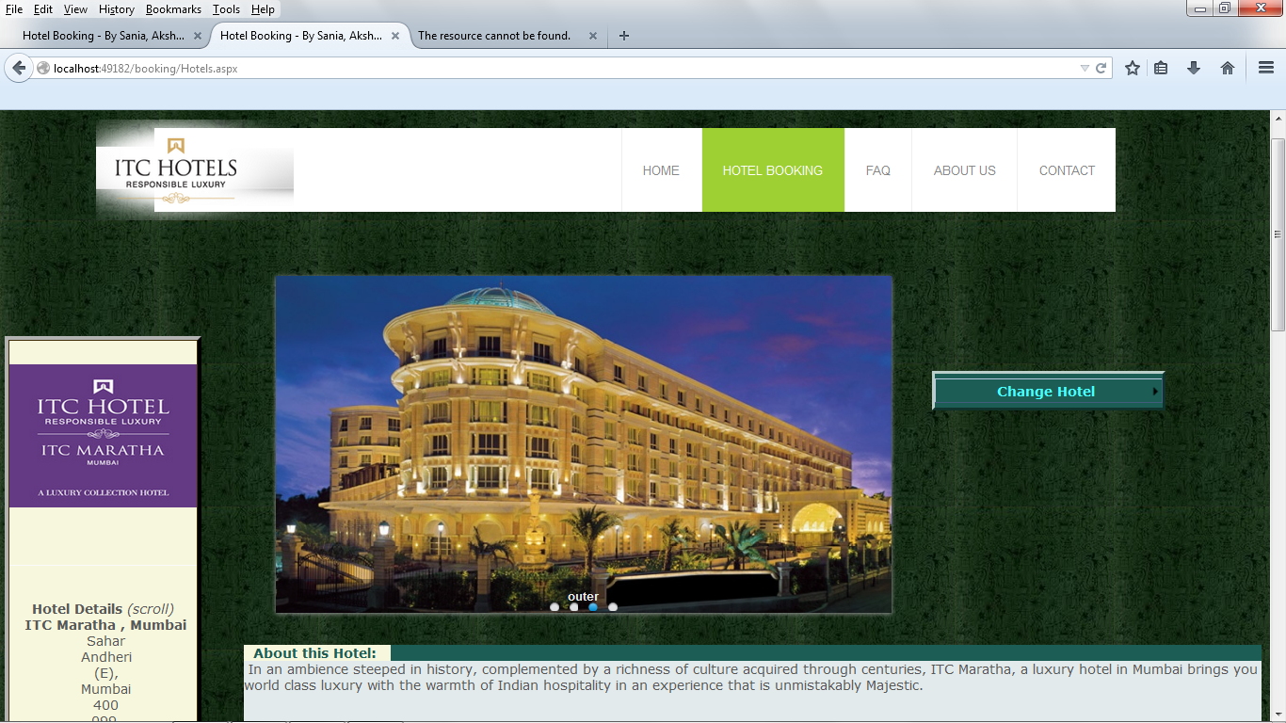

**Book Hotel Page**

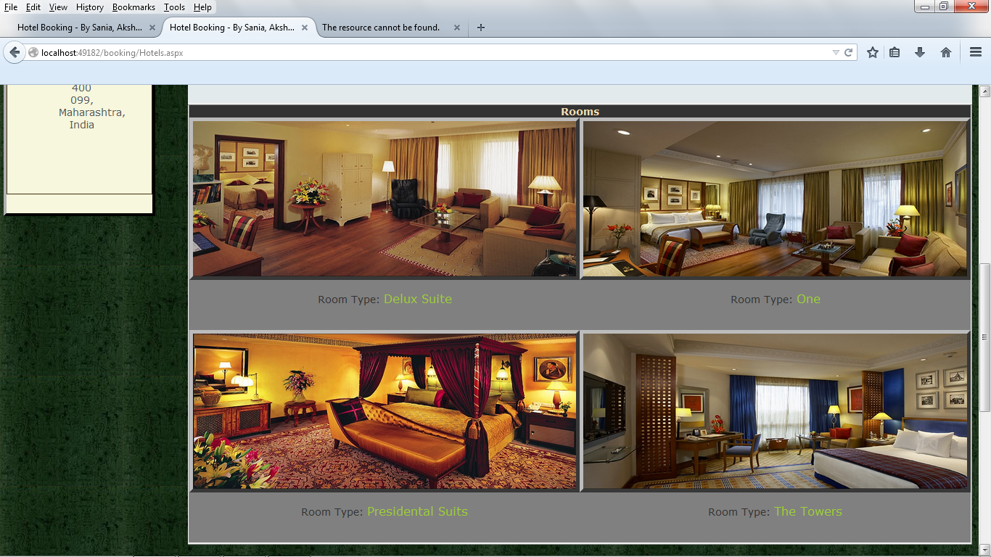

**Book hotel page- Hotel Specific Rooms**

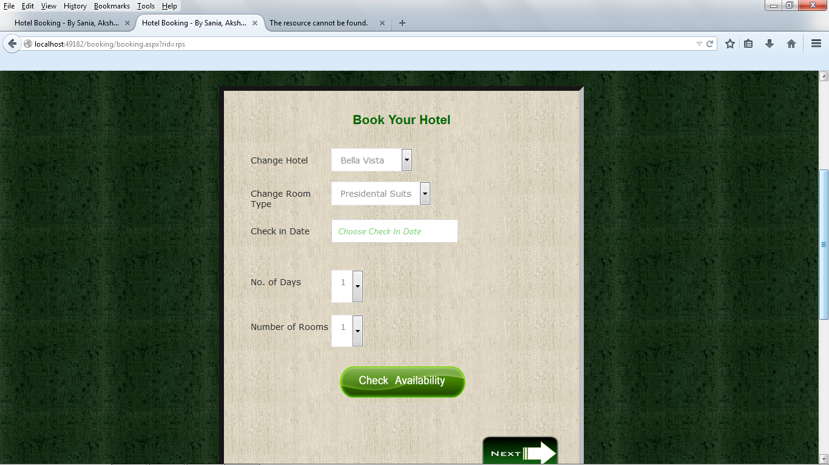

**Check Availability Page**

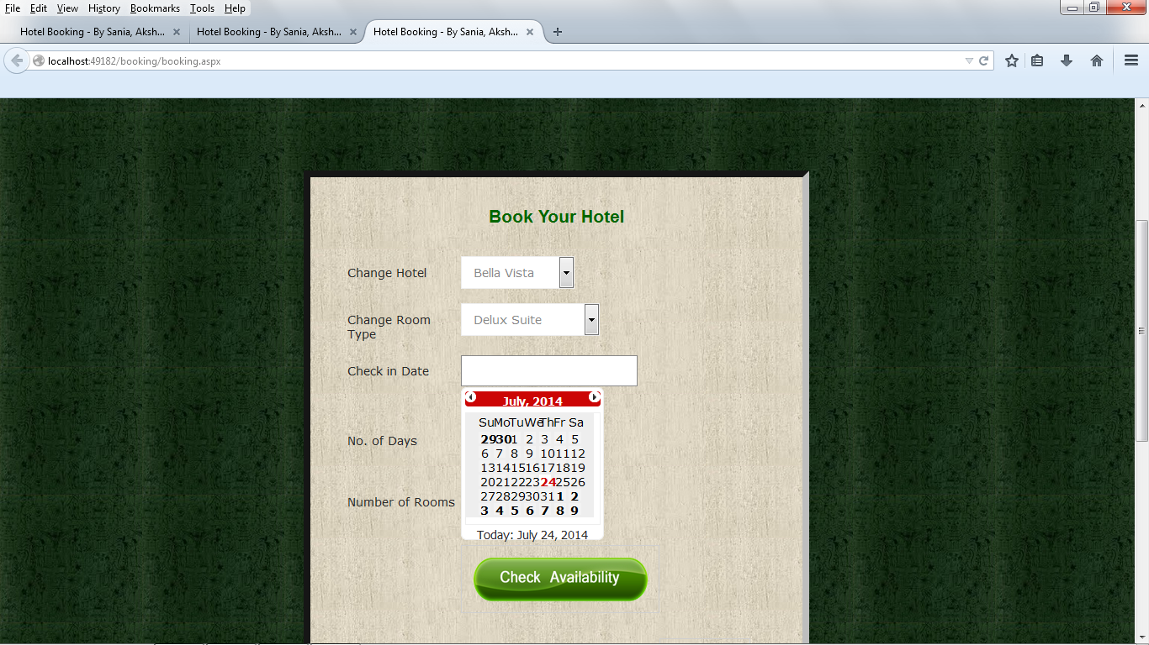

**Calendar Extender**

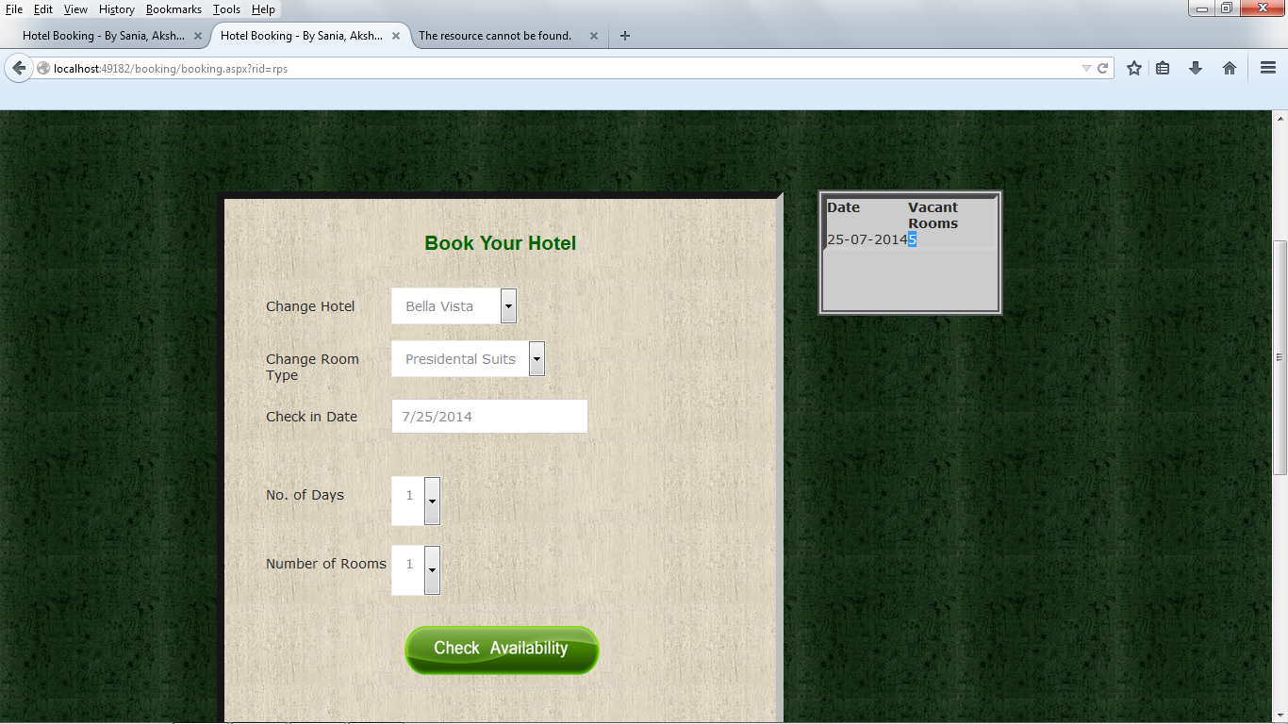**Room availability Check – available Rooms**

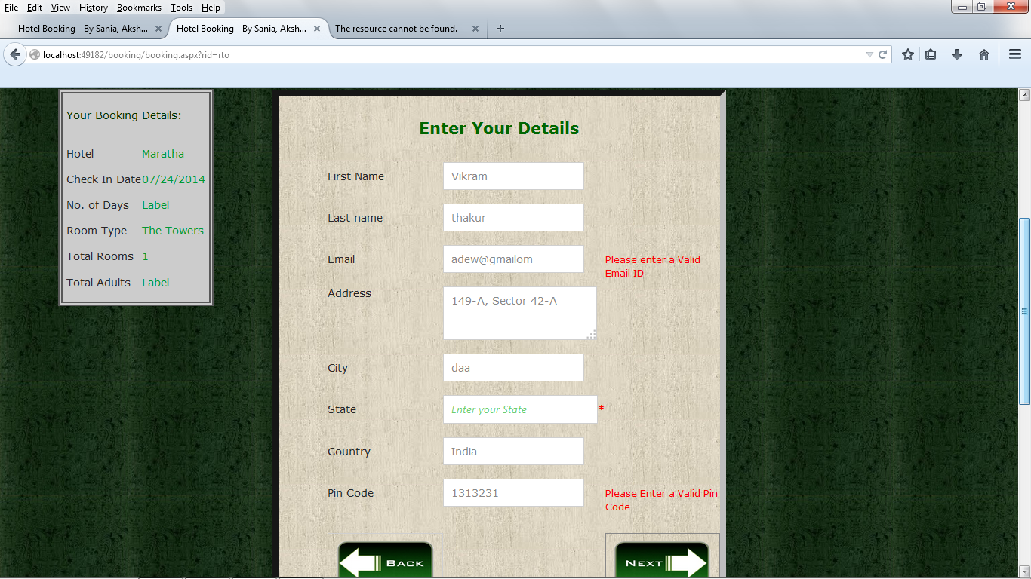

**Entering Details and Printing Previous information in a Panel/Table**

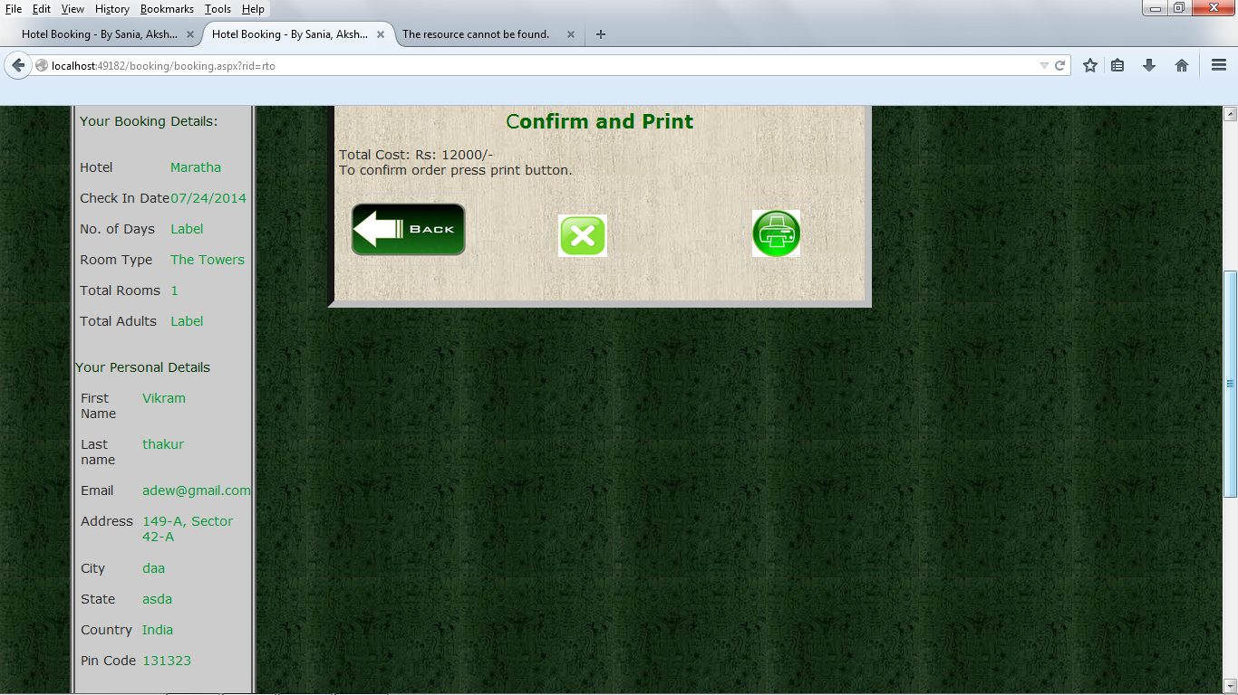

**Details Review, Go back/Print/Don’t Book**

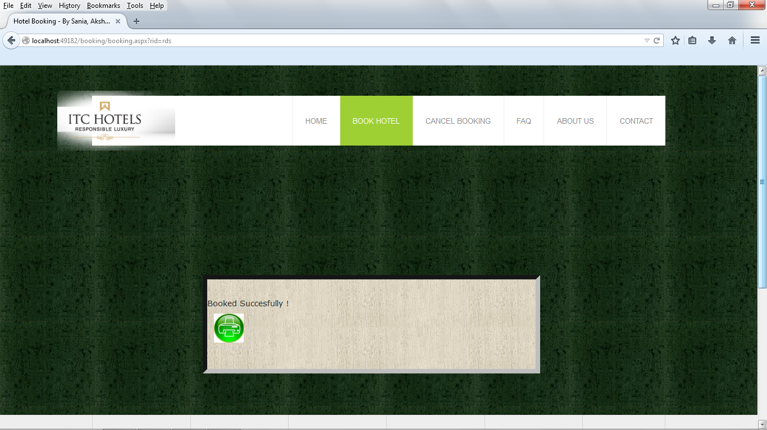

**Successful Booking Message**

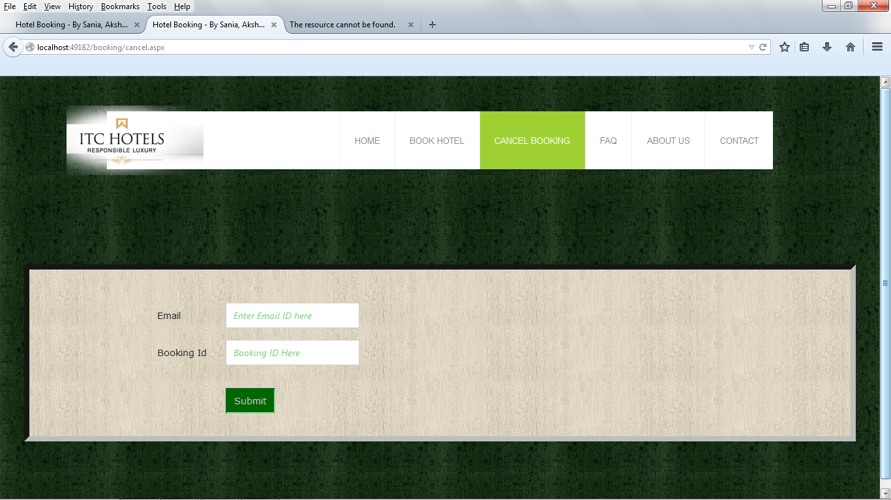

**Cancel Booking page**

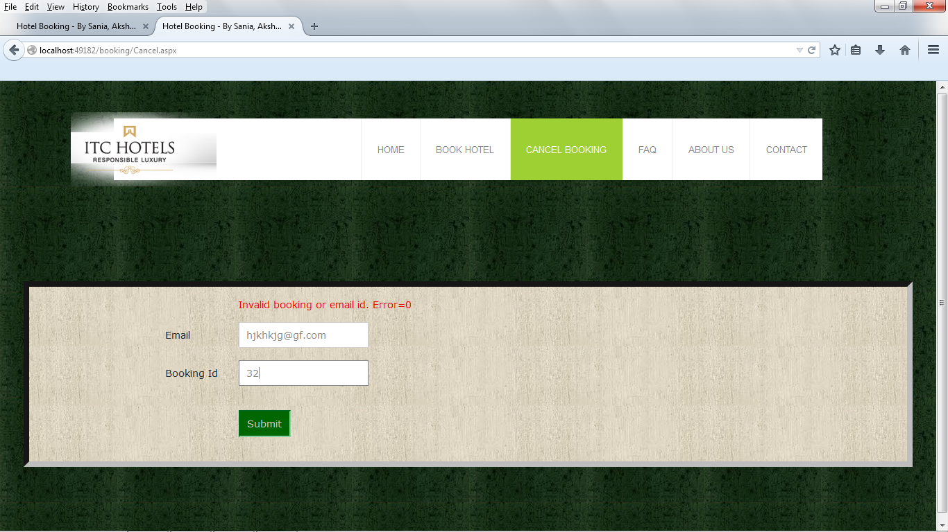

**Invalid email/bookingID message**

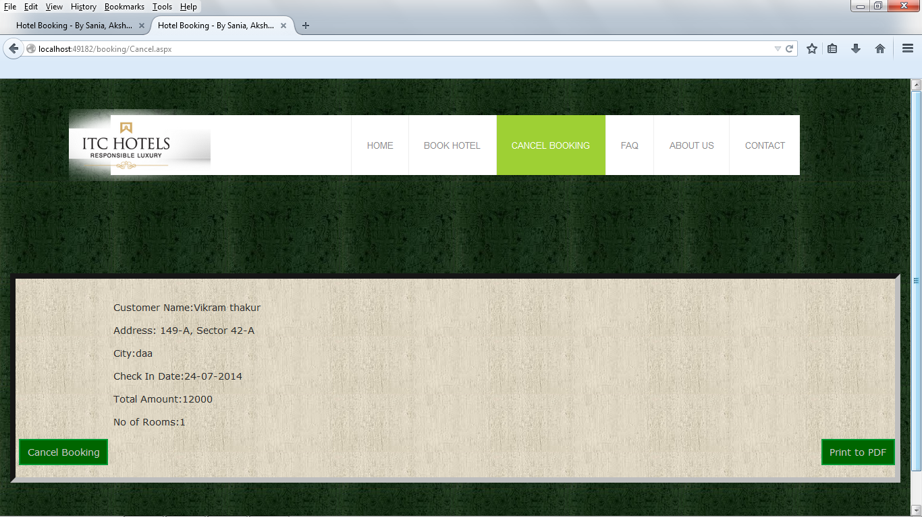

**Displaying information of booking to be cancelled**

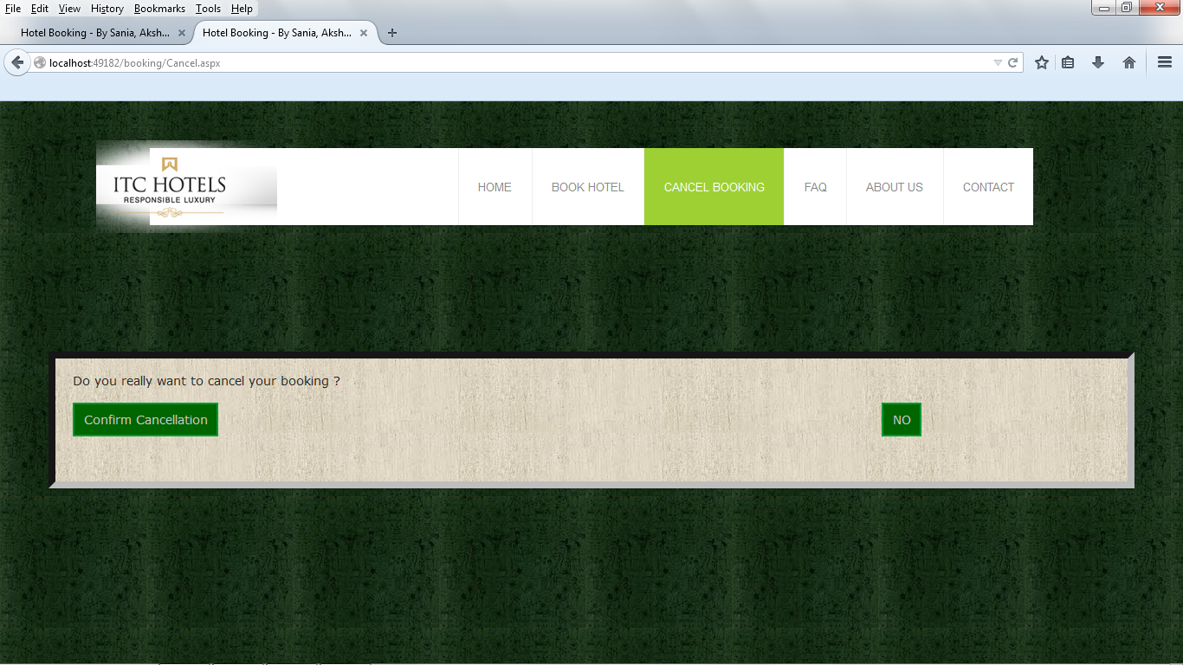

**Cancellation Confirmation Prompt**

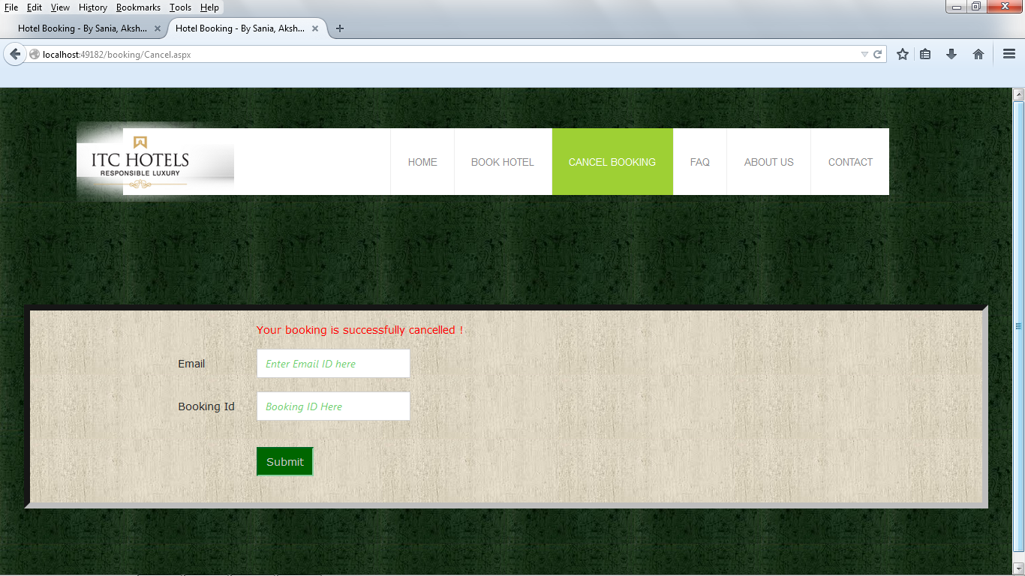

**Cancellation Confirmation Message**

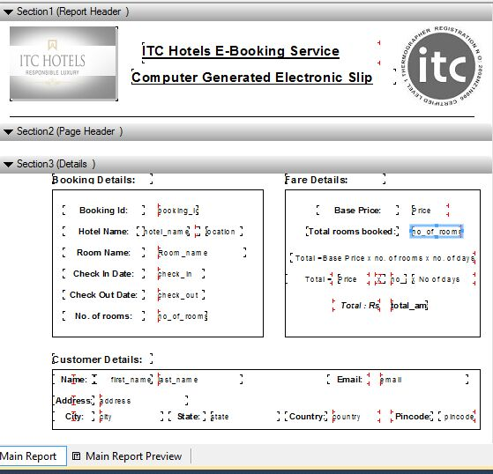

**Design of Crystal Report for Booking Details/E-Ticket Printout**

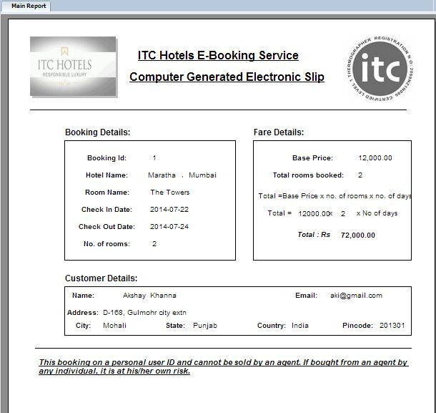

**Final Crystal Report for Booking Details/E-Ticket Printout**

**Snapshots – Databases**

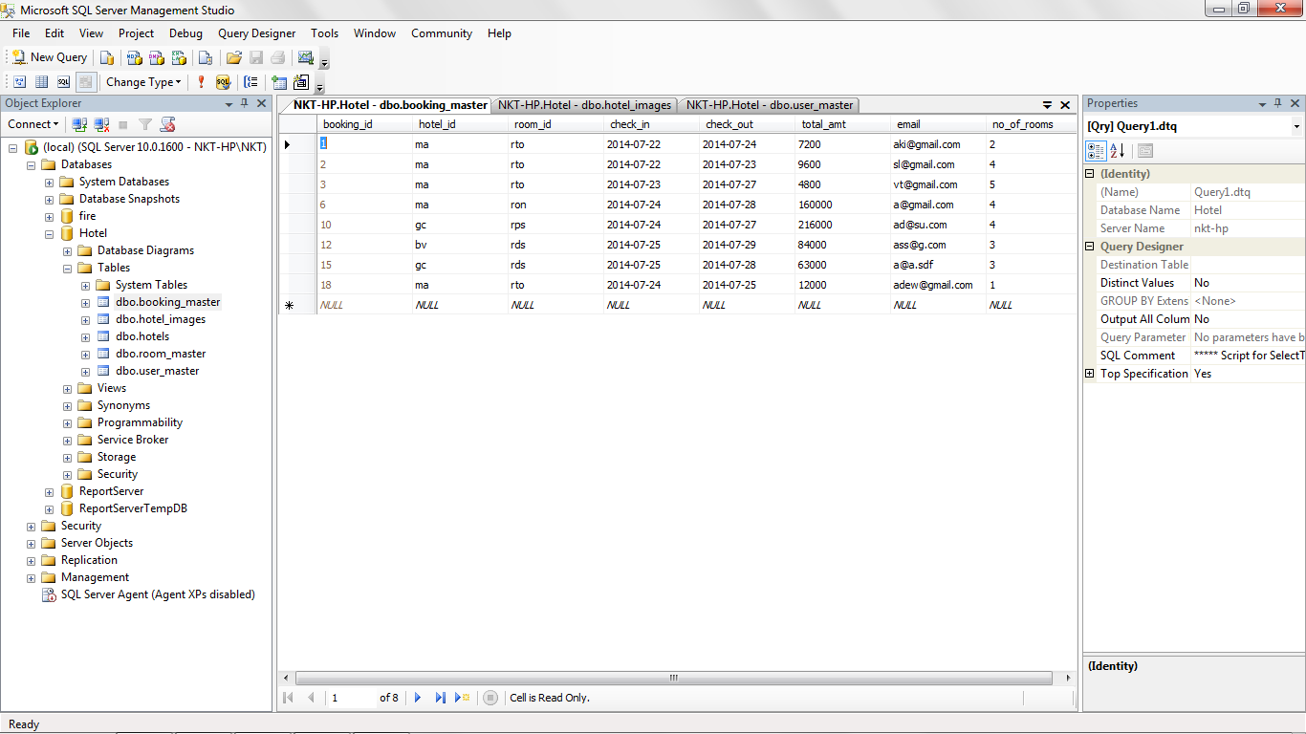

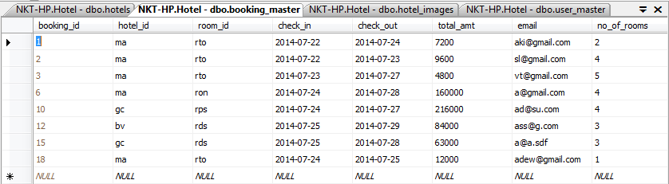

**Booking_Master table**

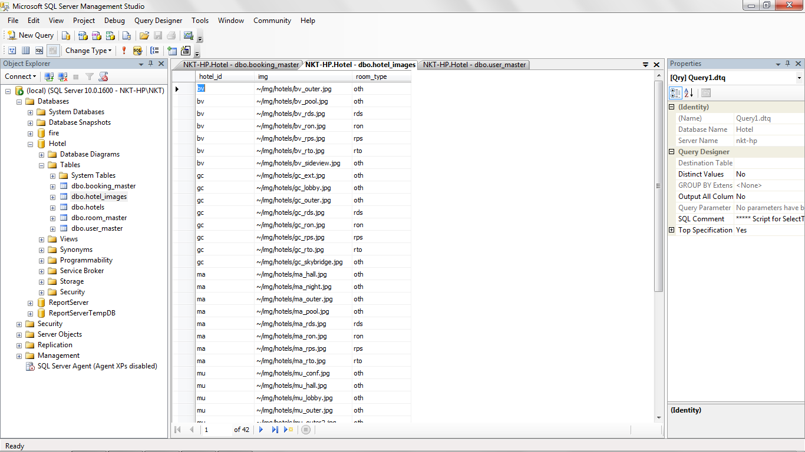

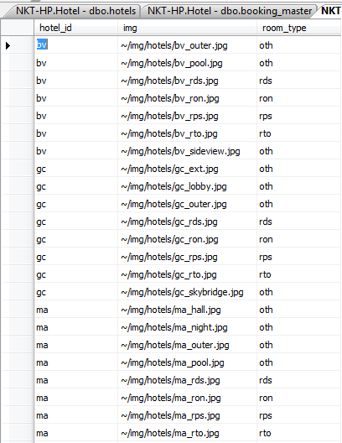

**Hotel Images path Table**

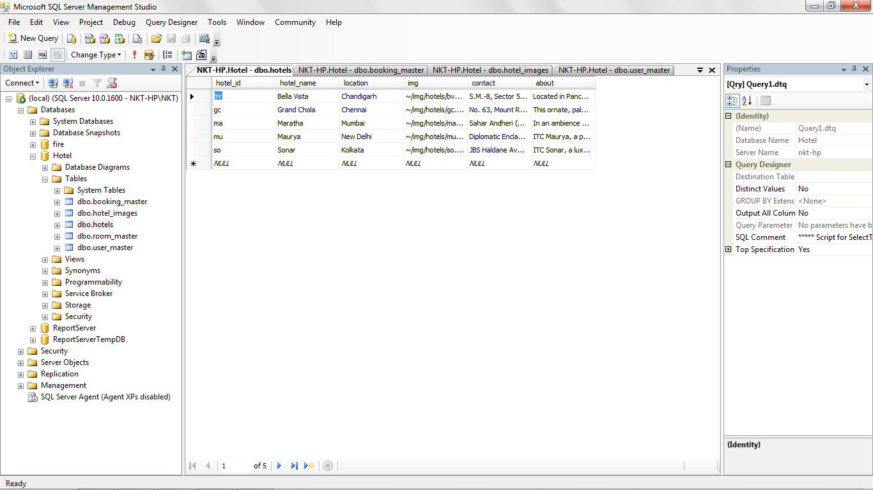

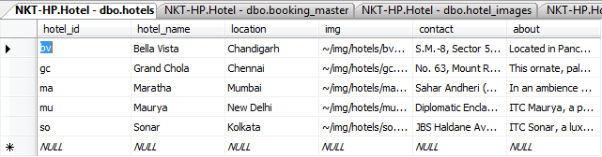

**Hotels Table**

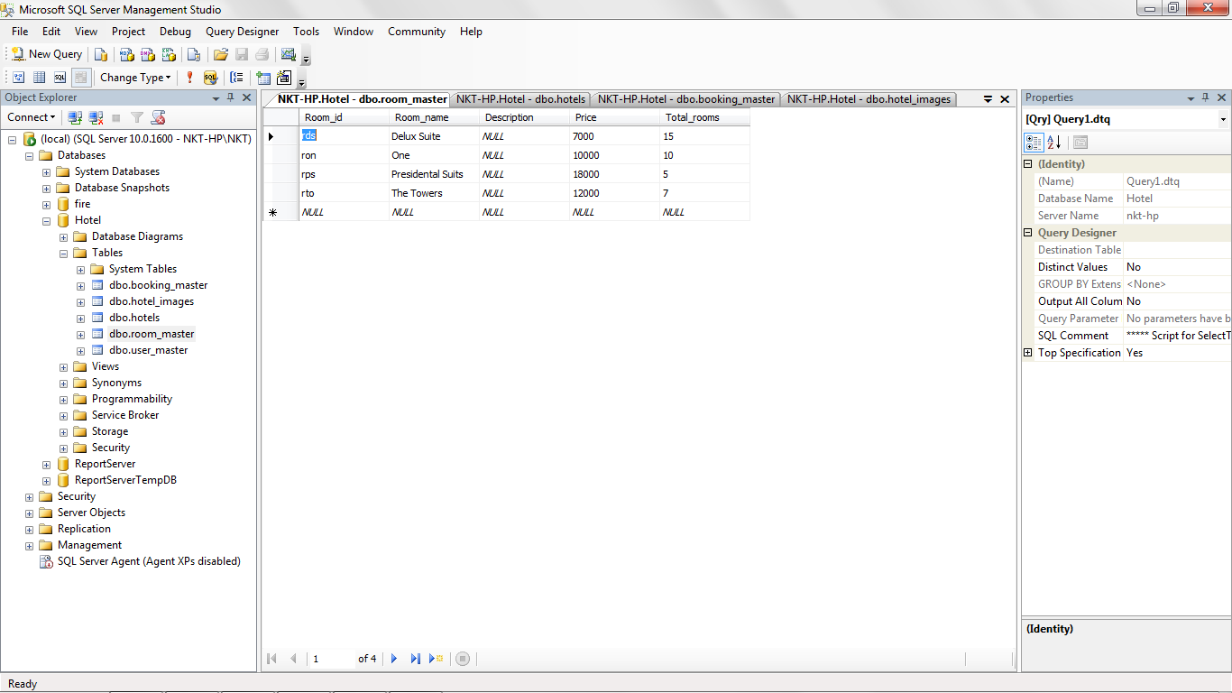

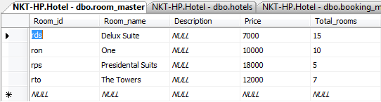

**Room Master Table**

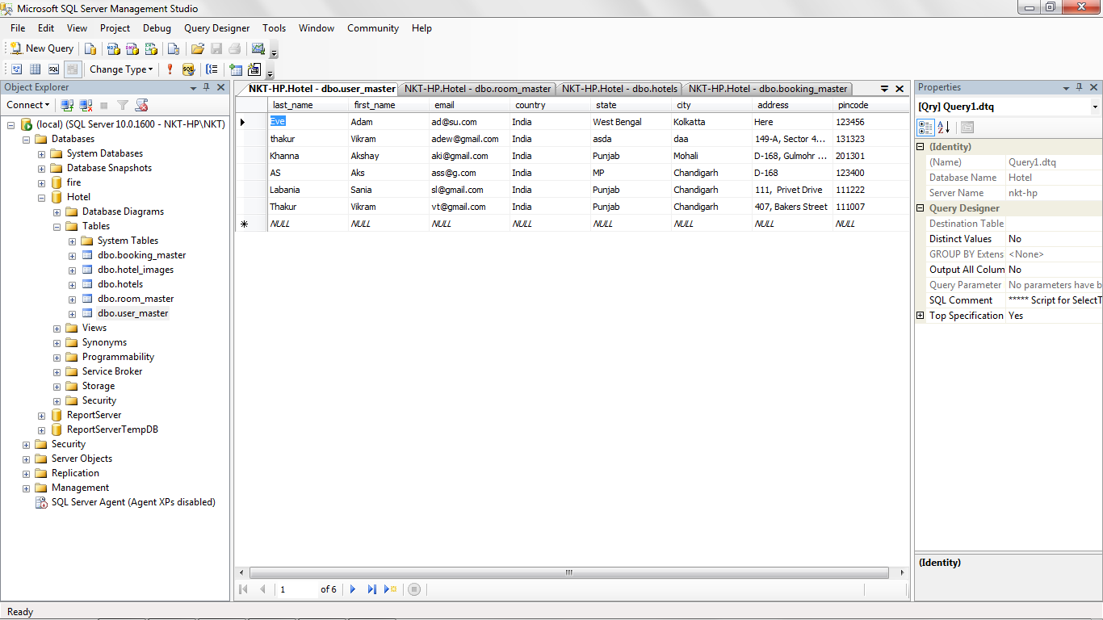

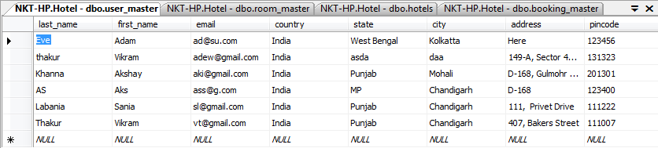

**User Master Table**

**SnapShots – Code**

**Hotels.aspx.cs**

public partial class Hotels : System.Web.UI.Page

{

String qs = "ma";

protected void Page_Load(object sender, EventArgs e)

{

if (Request.QueryString.Get("hot") != null)

qs = Request.QueryString.Get("hot");

Response.Write("Query String: " + qs);

imageSlider();

Session["hotel"] = qs;

}

void imageSlider()

{

SqlConnection con = new SqlConnection();

con.ConnectionString = "Data Source=(local);Initial Catalog=Hotel;Integrated Security=True";

con.Open();

String q = "Select img from dbo.hotel_images where room_type='oth' and hotel_id='" + qs + "'";

SqlCommand com = new SqlCommand(q, con);

SqlDataReader dr = com.ExecuteReader();

if (dr.Read())

{

String html = "<div id='sliderFrame'> <div id='slider'> ";

do

{

String img_ad = dr["img"].ToString();

// Response.Write(img_ad);

String img = img_ad.Substring(img_ad.IndexOf('/') + 1);

// Response.Write(img);

String cap = img.Substring(img.IndexOf('_') + 1, (img.LastIndexOf('.') - img.IndexOf('_') - 1));

// Response.Write(cap);

html += "<img src='" + img + "' alt='" + cap + "' /> ";

// Label1.Text = html;

} while (dr.Read());

html += "</div> </div> ";

Label1.Text = html;

}

else

Label1.Text = "Failed to load slider";

}

protected void DataList3_SelectedIndexChanged(object sender, EventArgs e)

{

}

protected void DataList1_SelectedIndexChanged(object sender, EventArgs e)

{

}

}

**Booking.aspx.cs**

public partial class booking : System.Web.UI.Page

{

public static int[] vac = new int[7];

public static DateTime[] all_date = new DateTime[7];

int room_req;

public static int no_of_days;

public static double total_amount;

protected void Page_Load(object sender, EventArgs e)

{

MultiView1.ActiveViewIndex = 0;

//DDLhotel.SelectedValue = Session["hotel"].ToString();

if (Request.QueryString.Get("rid") != null)

{

DDLroomtype.SelectedValue = Request.QueryString.Get("rid");

}

panel1.Visible = false;

}

protected void ImageButton1_Click(object sender, ImageClickEventArgs e)

{

Lb_status.Visible = true;

panel_avail.Visible = false;

checkAvailabilty();

Boolean flag=true;

room_req = Convert.ToInt32(DDLrooms.SelectedValue);

for (int i = 0; i < no_of_days; i++)

{

if (vac[i] == 0 || vac[i]<room_req)

{

flag = false;

// Response.Write(" Rooms are not available");

break;

}

}

if (flag)

{

MultiView1.ActiveViewIndex = 1;

panel1.Visible = true;

LBhotel.Text = DDLhotel.SelectedItem.ToString();

LBCheckin.Text = TBcheckin.Text;

//Label3.Text = TextBox2.Text;

LBRoomtype.Text = DDLroomtype.SelectedItem.ToString();

LBRooms.Text = DDLrooms.SelectedItem.ToString();

//LBAdults.Text = DDLadults.SelectedItem.ToString();

}

else

Lb_status.Text = "Sorry rooms are unavailable.";

}

protected void ImageButton2_Click(object sender, ImageClickEventArgs e)

{

no_of_days = Convert.ToInt32(DDLdays.SelectedValue);

total_amount = Convert.ToInt32(DDLdays.SelectedValue) * Convert.ToInt32(DDLrooms.SelectedValue);

SqlConnection con = new SqlConnection();

con.ConnectionString = "Data Source=(local);Initial Catalog=Hotel;Integrated Security=True";

con.Open();

String q = "Select room_master.Price from room_master where room_master.Room_id='"+DDLroomtype.SelectedValue+"'";

SqlCommand cmd = new SqlCommand(q, con);

SqlDataReader dr = cmd.ExecuteReader();

double base_price = 0 ;

if (dr.Read())

{

base_price = Convert.ToInt32(dr[0].ToString());

// Response.Write("Base price" + base_price + " Total amount:" + total_amount );

}

con.Close();

total_amount *= base_price;

Lb_total_amt.Text = " Total Cost: Rs: " + total_amount + "/- <br/> To confirm order press print button.";

MultiView1.ActiveViewIndex = 2;

panel1.Visible = true;

panel_userdetails.Visible = true;

LBFirstname.Text = TBfirstname.Text;

LBLastname.Text = TBlastname.Text;

LBemail.Text = TBemail.Text;

LBaddress.Text = TBaddress.Text;

LBcity.Text = TBcity.Text;

LBstate.Text = TBstate.Text;

LBcountry.Text = TBcountry.Text;

LBpin.Text = TBpin.Text;

}

protected void ImageButton3_Click(object sender, ImageClickEventArgs e)

{

no_of_days = Convert.ToInt32(DDLdays.SelectedValue);

SqlConnection con = new SqlConnection();

con.ConnectionString = "Data Source=(local);Initial Catalog=Hotel;Integrated Security=True";

con.Open();

DateTime dt = tb_Date_2_dateTime_var_format(TBcheckin.Text);

String c_in = date2Str4query(dt);

// DateTime dt_temp = all_date[no_of_days - 1].AddDays(1);

String c_out = date2Str4query(dt.AddDays(no_of_days));

//Response.Write("c_in " + c_in + " c_out " + c_out +" dt "+dt.ToShortDateString() + "all_date[0] "+ all_date[0] );

String q = "Insert into booking_master(hotel_id,room_id,check_in,check_out,email,no_of_rooms,total_amt) values('" + DDLhotel.SelectedValue + "','" + DDLroomtype.SelectedValue + "','" + c_in + "','" + c_out + "','" + TBemail.Text + "'," + DDLrooms.SelectedValue + "," + total_amount + ")";

// Response.Write("<br/> q=" + q);

SqlCommand cmd = new SqlCommand(q, con);

int i = cmd.ExecuteNonQuery();

// Response.Write("<br/> i=" + i);

con.Close();

if (i == 1)

{

SqlConnection con1 = new SqlConnection();

con1.ConnectionString = "Data Source=(local);Initial Catalog=Hotel;Integrated Security=True";

con1.Open();

String q1 = "insert into user_master(first_name,last_name,email,address,city,state,country,pincode) values('" + TBfirstname.Text + "','" + TBlastname.Text + "','" + TBemail.Text + "','" + TBaddress.Text + "','" + TBcity.Text + "','" + TBstate.Text + "','" + TBcountry.Text + "'," + Convert.ToInt32(TBpin.Text) + ")";

SqlCommand cmd1 = new SqlCommand(q1, con1);

int j = cmd1.ExecuteNonQuery();

//Response.Write(" j=" + j);

con1.Close();

if (j == 1)

{

MultiView1.ActiveViewIndex = 3;

Lb_Book_conf.Text = "Booked Succesfully !";

}

else

{

MultiView1.ActiveViewIndex = 3;

Lb_Book_conf.Text = "Failed !, unable to book. <br/> Please try again later. <br/> Error=105 ";

}

}

else

{

MultiView1.ActiveViewIndex = 3;

Lb_Book_conf.Text = "Booking Failed..! <br/> Please try again later. <br/> Error=100";

}

}

protected void ImageButton4_Click(object sender, ImageClickEventArgs e)

{

//ImageButton4.Visible = false;

}

protected void ImageButton4_Click1(object sender, ImageClickEventArgs e)

{

panel1.Visible = false;

panel_userdetails.Visible = false;

MultiView1.ActiveViewIndex = 0;

}

protected void ImageButton5_Click(object sender, ImageClickEventArgs e)

{

panel1.Visible = true;

panel_userdetails.Visible = false;

MultiView1.ActiveViewIndex = 1;

}

protected void DropDownList1_SelectedIndexChanged(object sender, EventArgs e)

{

}

protected void ib_check_avail_Click(object sender, ImageClickEventArgs e)

{

panel_avail.Visible = true;

checkAvailabilty();

//Lb_total.Text = "kuchh " + vac[4];

Lb_Avail.Visible = true;

String text = "<div id='avalibilty' class='table_class'>";

text+=" <table border='3px' cellpadding='12px' cellspacing='10px'><tr><td><b>Date</b></td><td><b> Vacant Rooms</b></td></tr>";

for (int i = 0; i < no_of_days; i++)

{

text += "<tr><td>" + all_date[i].ToShortDateString() + "</td>" + "<td>" + vac[i] + "</td></tr>";

}

// text += "</tr><tr>";

/*for (int i = 0; i < no_of_days; i++)

{

text += "<td>" + vac[i] + "</td>";

}*/

text += "</table></div>";

Lb_Avail.Text = text;

// Lb_Avail.Text = "<div id='avalibilty'> <table border='2px' cellpadding='5px'><tr><td><b>Date</b></td>" + all_date[0].ToShortDateString() + "<td></td></tr>"

// + "<tr><td><b> Vacant Rooms</b></td><td>" + vac[0] + "</td></tr></div>";

}

void checkAvailabilty()

{

//DateTime dt = Convert.ToDateTime(TextBox1.Text);

// DateTime dt = DateTime.Now

//dt.AddMonths(dt.Month);

//string dateTimeString = TextBox1.Text;

//String date = DateTime.ParseExact(dateTimeString, "dd/MM/yyyy", null).ToString("MM/dd/yyyy");

// String date = "21/07/2014";

String date = TBcheckin.Text;

// DateTime dt = Convert.ToDateTime(date);

String mm = date.Substring(0, date.IndexOf('/'));

String dd = date.Substring(date.IndexOf('/') + 1, (date.LastIndexOf('/') - date.IndexOf('/') - 1));

String yy = date.Substring(date.LastIndexOf('/') + 1);

no_of_days = Convert.ToInt32(DDLdays.SelectedValue);

//date.su

//int d = Convert.ToInt32(dd);

// int m = Convert.ToInt32(mm);

//int y = Convert.ToInt32(yy);

if (mm.Length == 1)

mm = "0" + mm;

if (dd.Length == 1)

dd = "0" + dd;

DateTime ch_in=Convert.ToDateTime(dd + "/" + mm + "/" + yy);

DateTime dt = ch_in;

//dt.AddDays(5);

// Response.Write(dd + " ");

// Response.Write(mm + " ");

// Response.Write(yy + " ");

// Response.Write(dt.ToShortDateString());

//String dc = yy + mm + dd;

//String ht="<div id='avalibilty'> <table border='2px' cellpadding='5px'><tr><td><b>Date</b></td><td><b>Vac rooms</b></td></tr>";

String dc="";

int total = dbTotalR();

int full_room;

//int[] vac = new int[7];

for (int i = 0; i < no_of_days; i++)

{

if (i > 0)

dt = dt.AddDays(1);

all_date[i] = dt;

//ht+=" <tr><td>"+ dt +"</td>";

dc = date2Str4query(dt);

// Response.Write(" # " + all_date[i].ToShortDateString());

full_room = dbCheck(dc);

vac[i] = total - full_room;

}

for (int i = 0; i < no_of_days; i++)

{

//Response.Write(" # "+vac[i]);

}

//dc = date2Str4query(dt);

//Response.Write("<br/> " + dc + "<br/>");

dc = yy + mm + dd;

// full_room = dbCheck(dc);

}

DateTime tb_Date_2_dateTime_var_format(String date)

{

// DateTime dt = Convert.ToDateTime(date);

String mm = date.Substring(0, date.IndexOf('/'));

String dd = date.Substring(date.IndexOf('/') + 1, (date.LastIndexOf('/') - date.IndexOf('/') - 1));

String yy = date.Substring(date.LastIndexOf('/') + 1);

no_of_days = Convert.ToInt32(DDLdays.SelectedValue);

//date.su

//int d = Convert.ToInt32(dd);

// int m = Convert.ToInt32(mm);

//int y = Convert.ToInt32(yy);

if (mm.Length == 1)

mm = "0" + mm;

if (dd.Length == 1)

dd = "0" + dd;

DateTime dt = Convert.ToDateTime(dd + "/" + mm + "/" + yy);

return dt;

}

String date2Str4query(DateTime dt)

{

String dc = "";

dc += dt.Year;

if (dt.Month.ToString().Length == 1)

dc += "0" + dt.Month;

else

dc += dt.Month;

if (dt.Day.ToString().Length == 1)

dc += "0" + dt.Day;

else

dc += dt.Day;

return dc;

}

int dbCheck(String dc)

{

SqlConnection con = new SqlConnection();

con.ConnectionString = "Data Source=(local);Initial Catalog=Hotel;Integrated Security=True";

con.Open();

String q = "Select SUM(no_of_rooms) from booking_master where hotel_id='" + DDLhotel.SelectedValue + "' and room_id='" + DDLroomtype.SelectedValue + "' and check_in<='" + dc + "' and check_out>'" + dc + "'";

SqlCommand com = new SqlCommand(q, con);

String t = "";

int x=0;

SqlDataReader dr = com.ExecuteReader();

if (dr.Read())

{ //Lb_total.Text ="Kuchhh "+dr[0].ToString();

t = dr[0].ToString();

}

//Response.Write(" vaue in t: " + t);

if (t != "")

x = Convert.ToInt32(t);

else

x = 0;

con.Close();

return x;

// dr[0].ToString();

}

int dbTotalR()

{

SqlConnection con = new SqlConnection();

con.ConnectionString = "Data Source=(local);Initial Catalog=Hotel;Integrated Security=True";

con.Open();

String q = "Select room_master.Total_rooms from room_master where room_master.Room_id='" + DDLroomtype.SelectedValue + "'";

SqlCommand com = new SqlCommand(q, con);

String t = "0";

SqlDataReader dr = com.ExecuteReader();

if (dr.Read())

// Lb_total.Text ="Kuchhh "+dr[0].ToString();

t = dr[0].ToString();

con.Close();

return Convert.ToInt32(t);

}

protected void ImageButton6_Click(object sender, ImageClickEventArgs e)

{

Response.Redirect("Booking.aspx");

}

}

**Cancel.aspx.cs**

public partial class Cancel : System.Web.UI.Page

{

protected void Page_Load(object sender, EventArgs e)

{

MultiView1.ActiveViewIndex = 0;

}

protected void Bt_submit_Click(object sender, EventArgs e)

{

String text = "";

SqlConnection con = new SqlConnection();

con.ConnectionString = "Data Source=(local);Initial Catalog=Hotel;Integrated Security=True";

con.Open();

String q = "Select * from booking_master where booking_master.email='"+tb__email.Text+"' and booking_master.booking_id="+Tb_Booking_id.Text;

SqlCommand com = new SqlCommand(q, con);

SqlDataReader dr = com.ExecuteReader();

String text1 = "";

if (dr.Read())

{

DateTime dt = Convert.ToDateTime(dr["check_in"].ToString());

text1 = "<br/><br/> Check In Date:" + dt.ToShortDateString() + "<br/><br/> Total Amount:" + dr["total_amt"].ToString() + "<br/><br/> No of Rooms:" + dr["no_of_rooms"].ToString();

con.Close();

SqlConnection con2 = new SqlConnection();

con2.ConnectionString = "Data Source=(local);Initial Catalog=Hotel;Integrated Security=True";

con2.Open();

String q2 = "Select user_master.first_name, user_master.last_name, user_master.address , user_master.city from user_master where user_master.email='"+tb__email.Text+"'";

SqlCommand com2 = new SqlCommand(q2, con2);

SqlDataReader dr2 = com2.ExecuteReader();

if (dr2.Read())

{

text = " Customer Name:" + dr2["first_name"].ToString() + " " + dr2["last_name"].ToString() + "<br/><br/>" + "Address: " + dr2["address"].ToString() +

"<br/><br/> City:" + dr2["city"].ToString();

con2.Close();

text += text1;

MultiView1.ActiveViewIndex = 1;

Lb_details.Text = text;

}

else

{

con2.Close();

Lb_details.Text = "Invalid booking or email id. Eror=0.5";

tb__email.Text = "";

Tb_Booking_id.Text = "";

}

}

else

{

con.Close();

Lb_invalid.Visible = true;

Lb_invalid.Text = "Invalid booking or email id. Error=0";

tb__email.Text = "";

Tb_Booking_id.Text = "";

} }

protected void Bt_Conf_Cancel_Click(object sender, EventArgs e)

{

MultiView1.ActiveViewIndex = 2;

}

protected void Bt_yes_canc_Click(object sender, EventArgs e)

{

SqlConnection con = new SqlConnection();

con.ConnectionString = "Data Source=(local);Initial Catalog=Hotel;Integrated Security=True";

con.Open();

String q = "Delete from booking_master where booking_id='" + Tb_Booking_id.Text + "'";

SqlCommand com = new SqlCommand(q, con);

int i = com.ExecuteNonQuery();

con.Close();

if (i == 1)

{

SqlConnection con2 = new SqlConnection();

con2.ConnectionString = "Data Source=(local);Initial Catalog=Hotel;Integrated Security=True";

con2.Open();

String q2 = "Delete from user_master where email='" + tb__email.Text + "'";

SqlCommand com2 = new SqlCommand(q2, con2);

int j = com2.ExecuteNonQuery();

con2.Close();

if (j == 1)

{

Lb_invalid.Visible = true;

Lb_invalid.Text = "Your booking is successfully cancelled !";

tb__email.Text = "";

Tb_Booking_id.Text = "";

}

else

{

Lb_invalid.Visible = true;

Lb_invalid.Text = "Cannot cancel your booking. Error=0.5";

tb__email.Text = "";

Tb_Booking_id.Text = "";

}

}

else

{

Lb_invalid.Visible = true;

Lb_invalid.Text = "Unable to cancel your booking. Error=0";

tb__email.Text = "";

Tb_Booking_id.Text = "";

}

MultiView1.ActiveViewIndex = 0;

}

protected void Bt_no_Click(object sender, EventArgs e)

{

MultiView1.ActiveViewIndex=1;

}

protected void Bt_print_Click(object sender, EventArgs e)

{

Response.Redirect("report.aspx?bid="+Tb_Booking_id.Text); } }